Dear Practitioner,

Volunteer State Community College has an AVMA accredited Veterinary Technician Program. This is a two year competitive AAS degree. Students must apply in the Spring for one of the 24 Fall openings. As part the application, students must complete 20 hours of observation in a veterinary facility. We want them to see what technicians actually do. They need to know it is not all cuddling puppies and kittens.
Please consider allowing students the opportunity to observe your practice. They do not need to do anything, just watch. We want them to see the good, the bad, and the ugly. We just ask that you complete one of our observation forms for them. Just stating the number of hours they observed at your practice. Students do not need to do all the hours in one location, so any time you can allow would be appreciated.
With Tennessee Promise in full swing, we will have about a hundred freshman interested in a veterinary career this summer alone. The observation hours may be the first time many of them have ever been exposed to animals beyond owning one. This experience will help students define their future. You may even have some asking you the difference between what you do and the technician’s responsibilities. I hope you will find the time to help them.
If you have any questions about the program, please do not hesitate to call or email me.

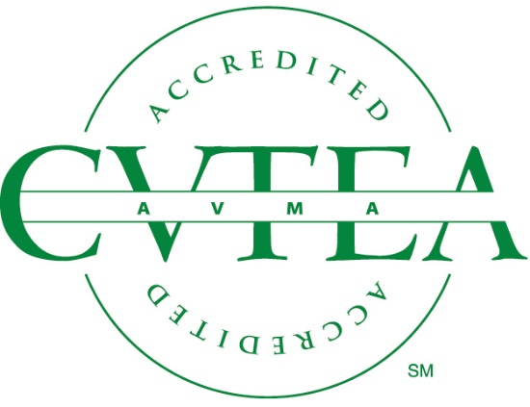
Hope Wright DVM
Program Director Veterinary Technology
Volunteer State Community College
615-230-3279
Hope.wright@volstate.edu

